|  |  |
| --- | --- |
| A picture of a winding road and trees  GIFT FINDER  MIDTERM EXAM | Vura, Venkata Vamsi Siva Krishna (UMKC-Student)  Advanced software engineering |

Introduction:

Generally finding gifts is a hard task, so instead if the person himself the gifts whatever he wants on his profile page and it is easy for the people coming and also no one can bring the same gift.

In this project I implemented

The **Profile page** includes

Username

Email ID

Password

Phone number

Location

The **login page**

Email ID

Password

After entering into the login page we have options

1. Send
2. Receive.

If we select option sending then we can select the gifts for the local database and enter the email id of the friends to be send

In option receiving we have the details of the gifts that have been sent by the friends.

We have the details of the friend such as his name, email ID and the photo of the gift that has been our friend.

The gifts are get from the link

[www.jabong.com](http://www.jabong.com)

[www.ebay.com](http://www.ebay.com)

[www.hdwallpapers.in](http://www.hdwallpapers.in)

**Software’s used:**

Jdk1.6

Apache tomcat 7

MySQL 5.6

In my SQL database:

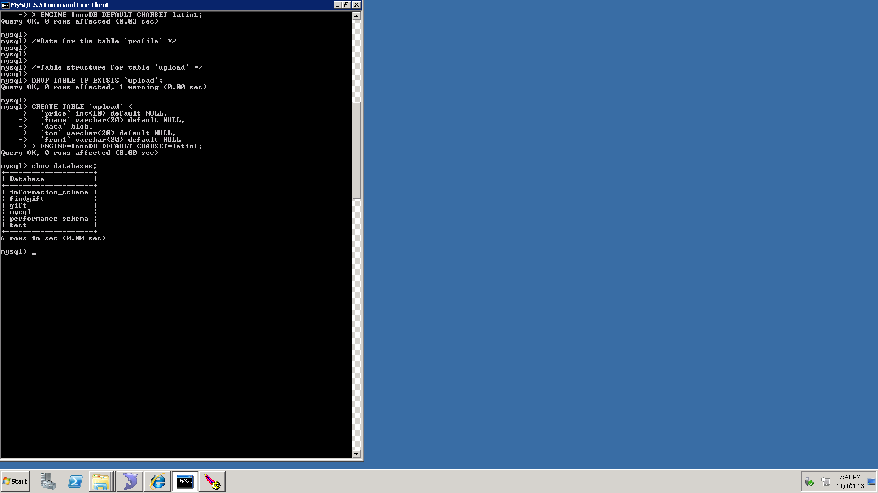

The details of the friends entered are saved in database as follows:

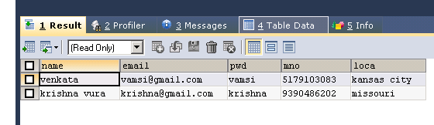

Here I used SQL yog, a GUI tool for my SQL

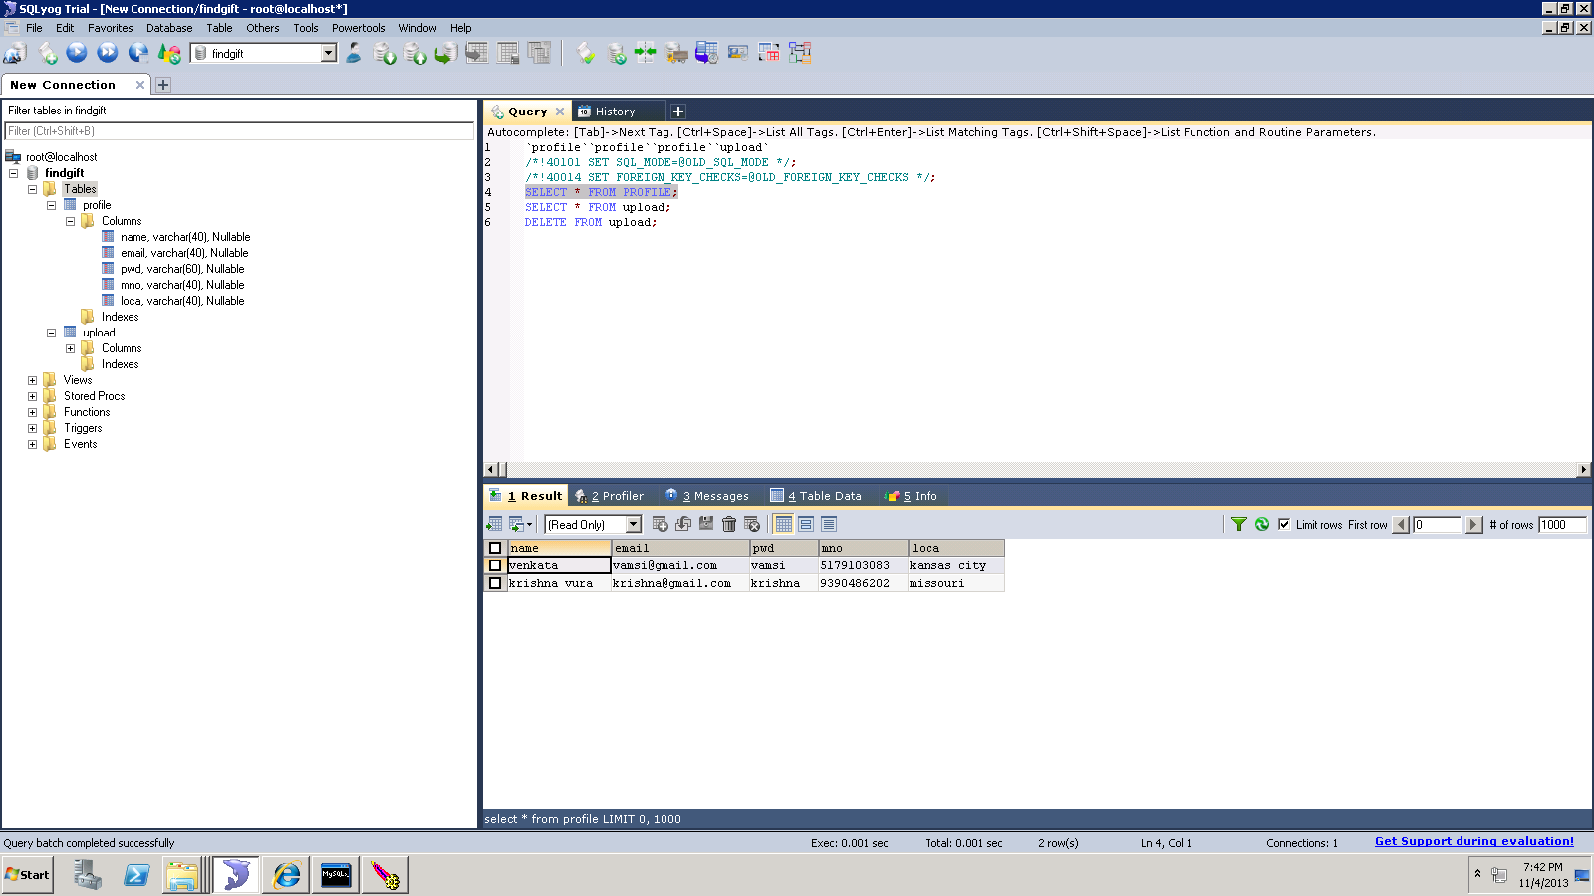

Whenever a friend receives a gift from another, then the details such as email address, gift picture ID and the user can view it

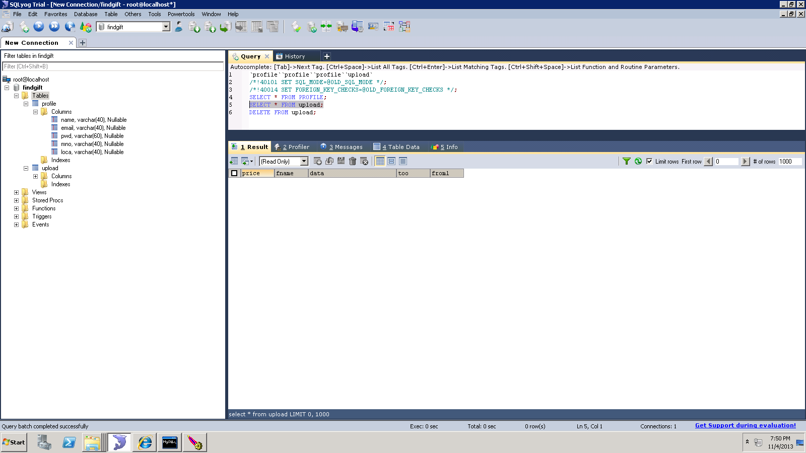

Inserting the profile:

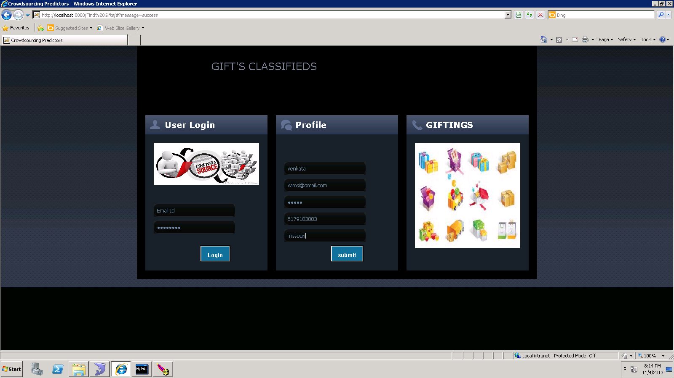

Showing the creation of profile is success in the task bar:

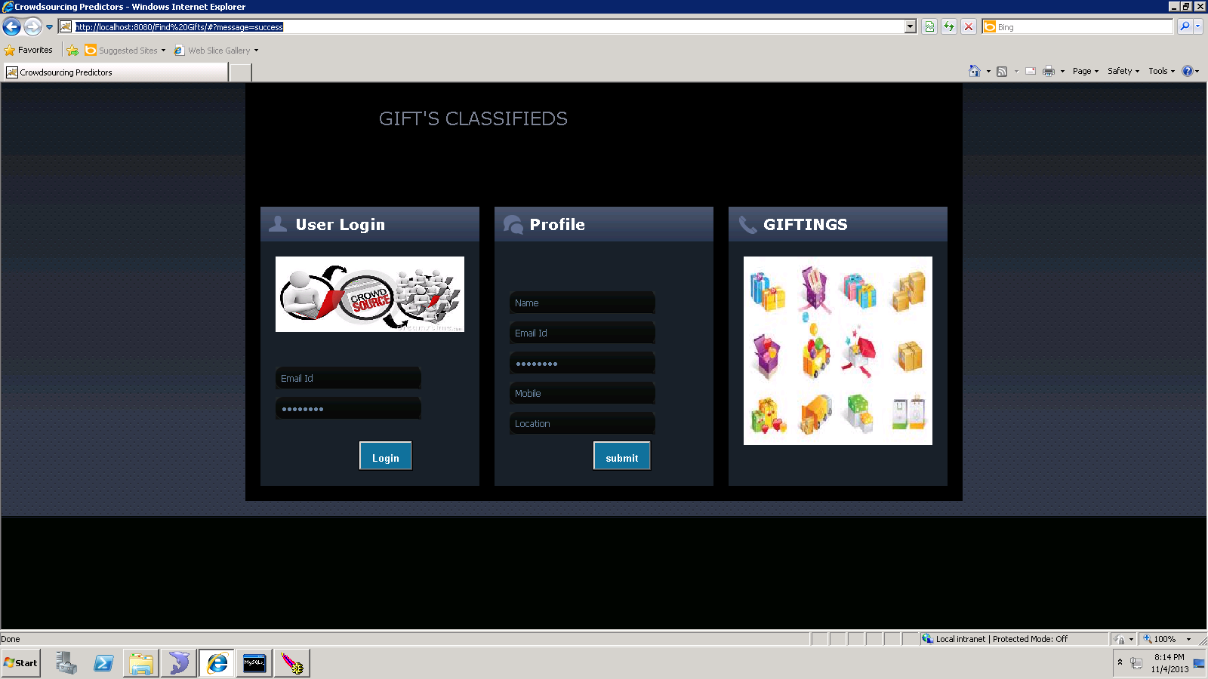

After login the gift page appears as:

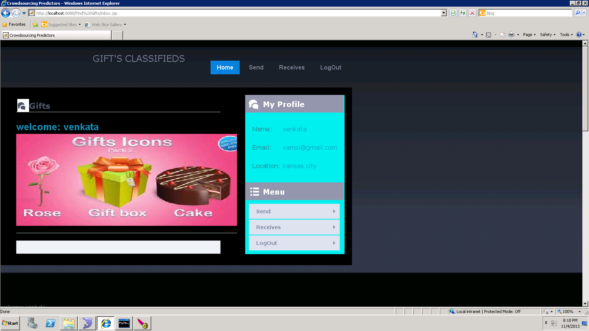

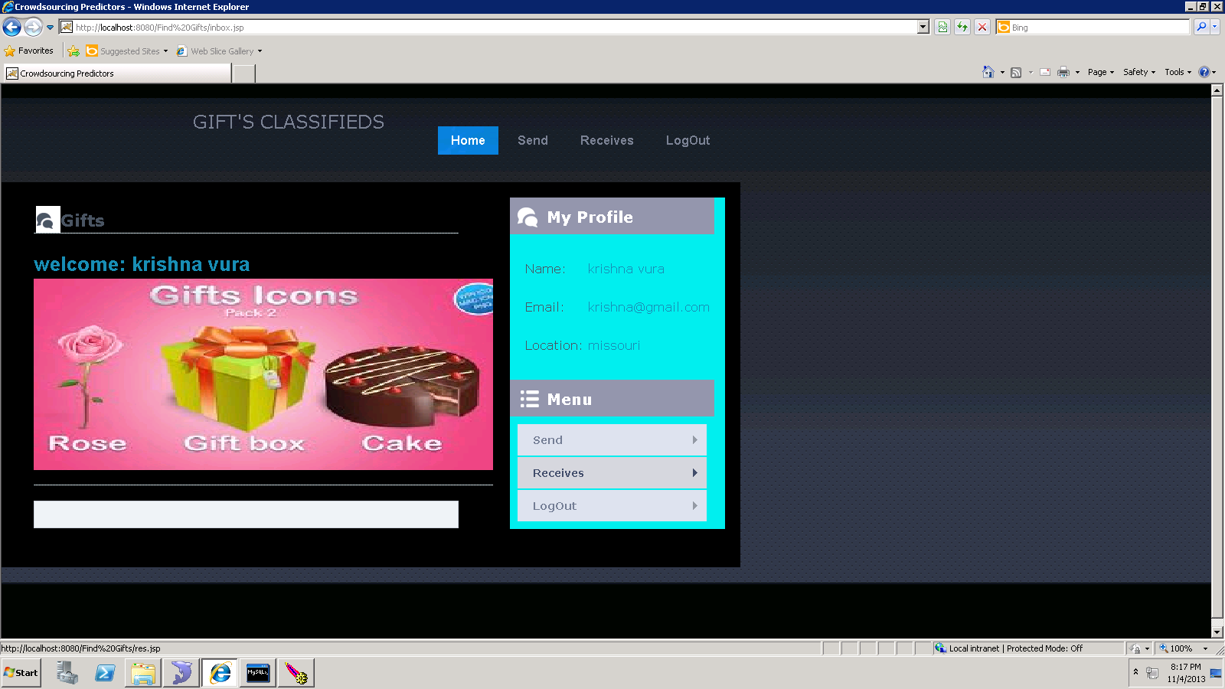

Whenever the web page opens all the details of the person will appear such as name, email ID and location.

Choosing the gift from the data base and sending it to the friend already who is the user

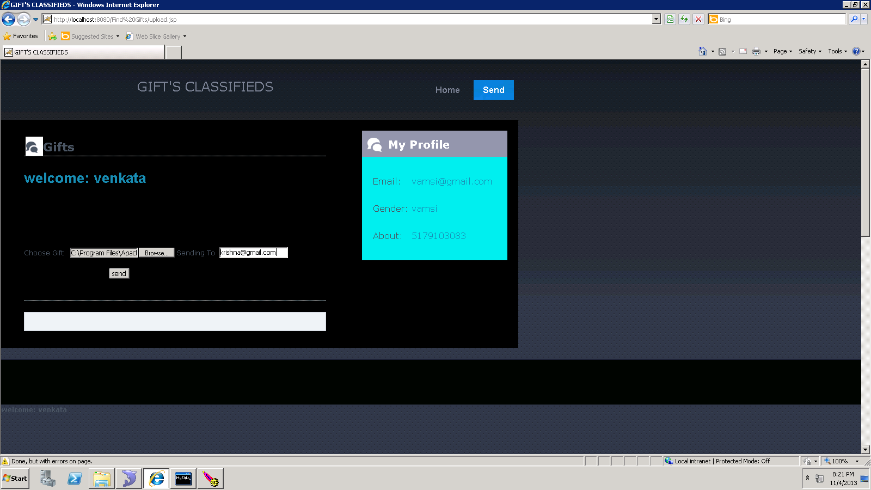

After clicking the submit button it shows at the task bar as “message=success”

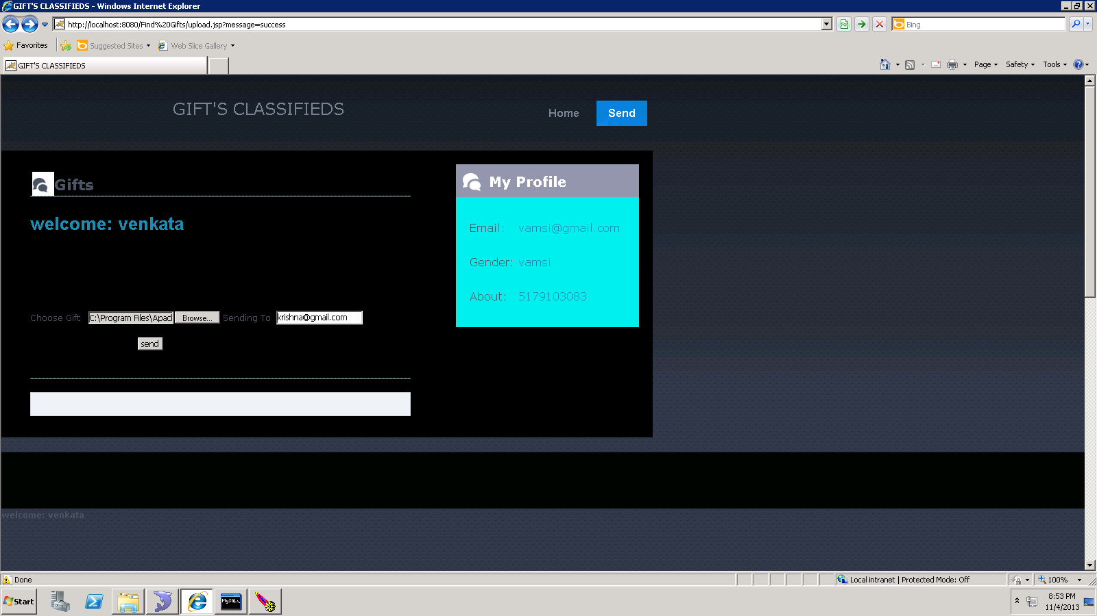

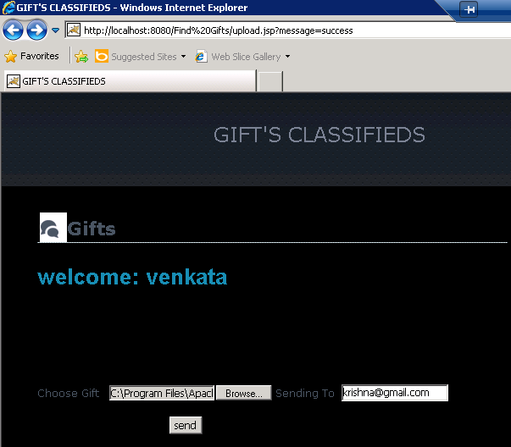

After receiving any gift from the friend you can find the details as follows:

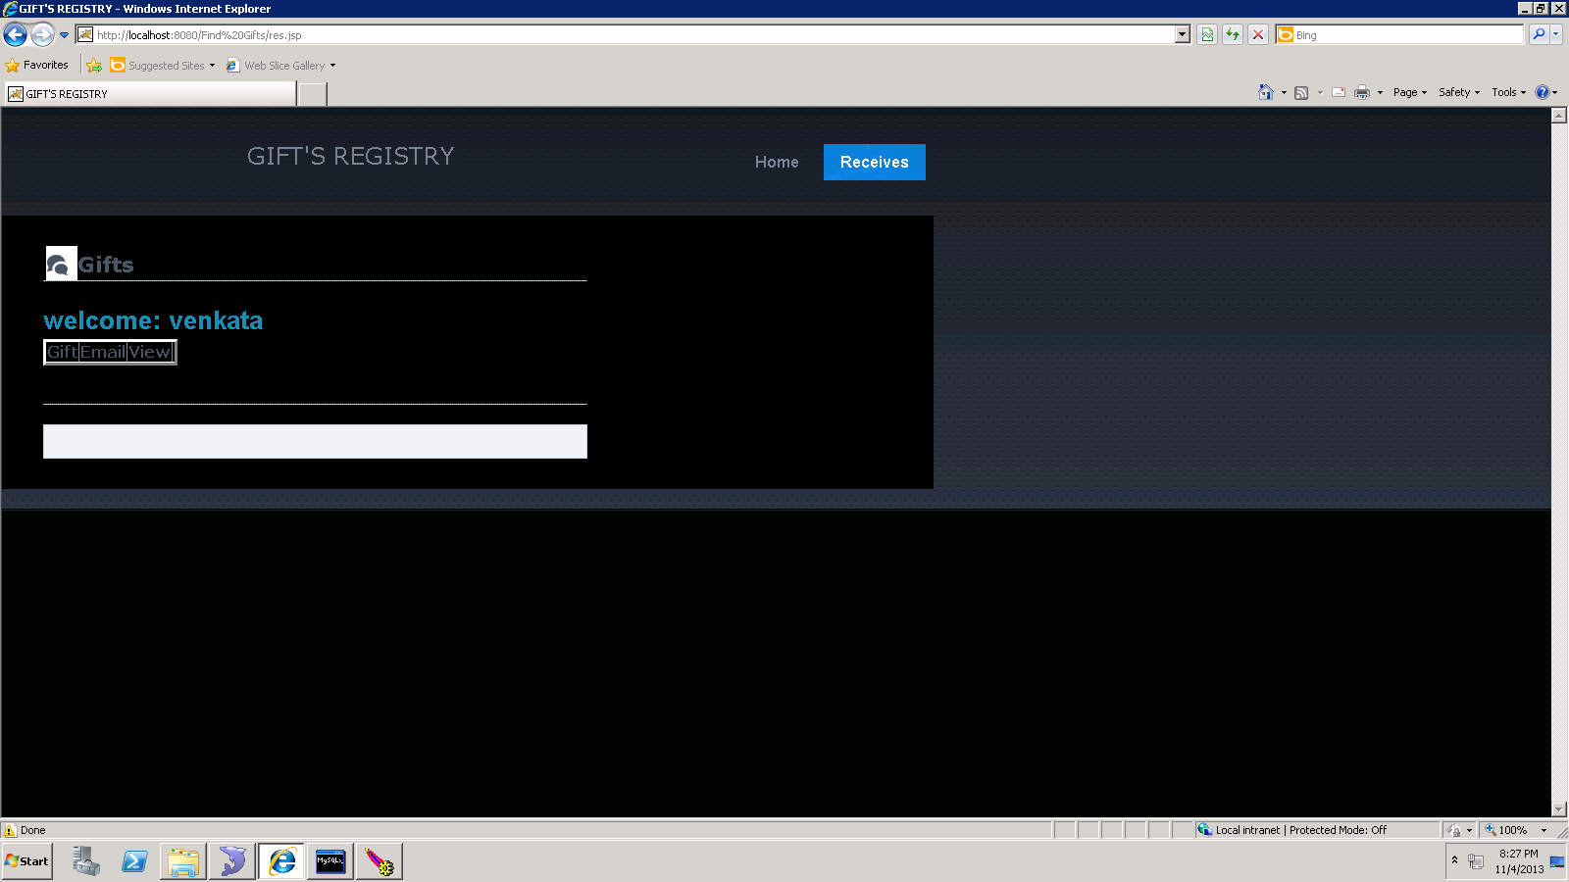

In above screen shoot in the white box,

We can see

The id of the gift in the database,

Email of the friend who send the gift,

View--- by clicking view we can see the picture of the gift.

Testing:

If we enter username and password wrong it shows exception

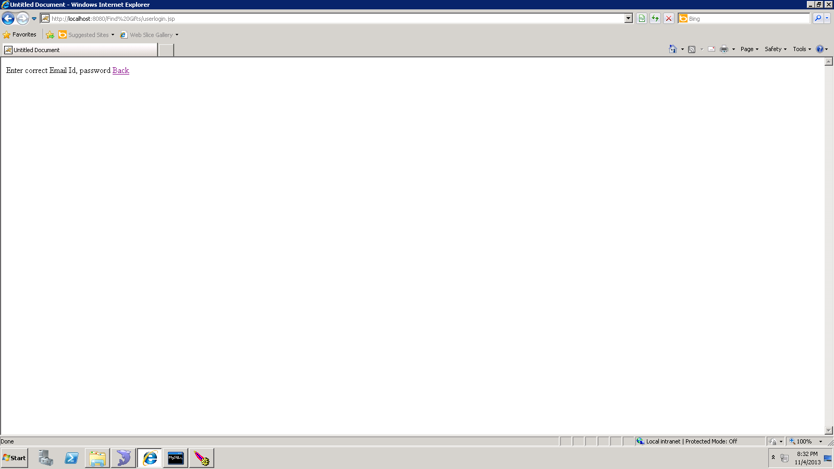

**Creation of MySQL data base:**

create database if not exists `findgift`;

USE `findgift`;

/*Table structure for table `profile` */

DROP TABLE IF EXISTS `profile`;

CREATE TABLE `profile` (

`name` varchar(40) default NULL,

`email` varchar(40) default NULL,

`pwd` varchar(60) default NULL,

`mno` varchar(40) default NULL,

`loca` varchar(40) default NULL

) ENGINE=InnoDB DEFAULT CHARSET=latin1;

/*Table structure for table `upload` */

DROP TABLE IF EXISTS `upload`;

CREATE TABLE `upload` (

`Price` int(10) default NULL,

`fname` varchar(20) default NULL,

`data` blob,

`too` varchar(20) default NULL,

`from1` varchar(20) default NULL

) ENGINE=InnoDB DEFAULT CHARSET=latin1;